6. Champagne Tower

Aim

To implement the Champagne Tower problem using Dynamic Programming and analyze its time and space complexity.

Algorithm

Start.

Read the number of cups poured, the target row, and the target glass.

Create a two-dimensional array and initialize all values to zero.

Store the poured amount in the top glass.

Traverse each row from top to bottom.

If a glass contains more than one cup, calculate the overflow.

Divide the overflow equally between the two glasses below it.

Repeat until the target row is reached.

Return the amount in the target glass, capped at one cup.

Stop.

Procedure

Initialize a two-dimensional array to store the amount of champagne in each glass.

Set the first glass to the total amount poured.

Traverse each row and check whether a glass overflows.

Distribute the excess champagne equally to the two glasses in the next row.

Continue the process until the required row is reached.

Return the target glass value, ensuring it does not exceed 1 cup.

Display the result.
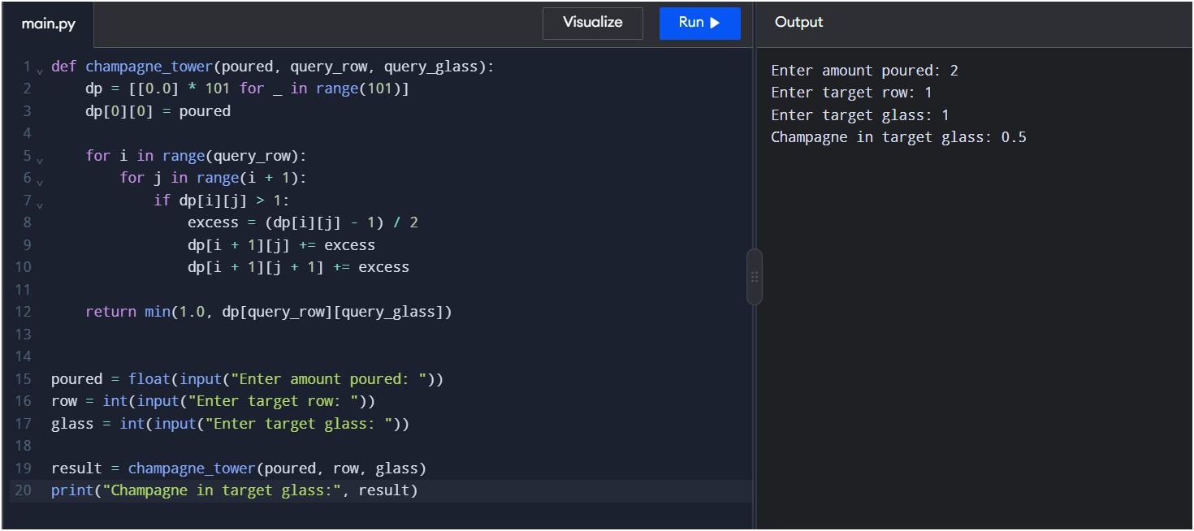

Result
Thus, the Champagne Tower problem was successfully implemented using Dynamic Programming. The amount of champagne in the specified glass was calculated by distributing the excess champagne equally between the glasses below it.

